With the hybrid animals, after they have described/drawn the animal based off their partners description, I often have the students talk in Spanish and come up with a name for the creatre. For example: The lion/eagle could be Leguila (león y águila)

[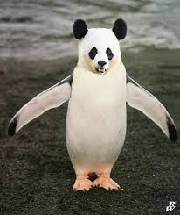](http://www.google.com/url?sa=i&rct=j&q=&esrc=s&source=images&cd=&cad=rja&uact=8&ved=0CAcQjRw&url=http%3A%2F%2Fdwarf4r.deviantart.com%2Fart%2FPanguin-400374916&ei=5HDnVODgOsKXgwSCt4TgBQ&bvm=bv.86475890,d.eXY&psig=AFQjCNGTTAxXRy3LMQHZs46FZsN8x6O-gA&ust=1424540223910039)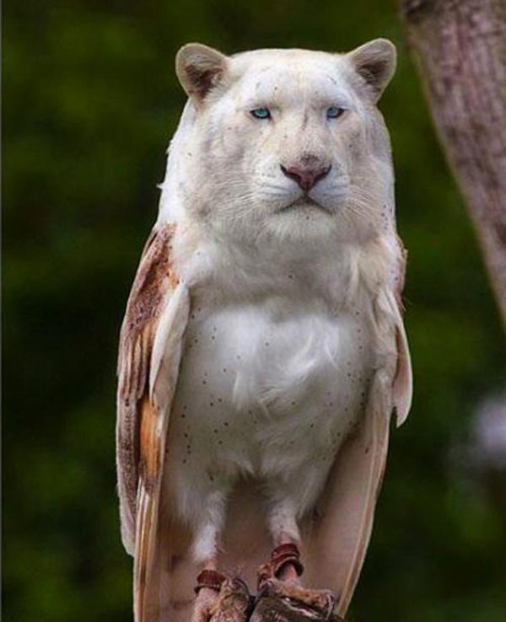

[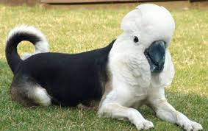](http://www.google.com/url?sa=i&rct=j&q=&esrc=s&source=images&cd=&cad=rja&uact=8&ved=0CAcQjRw&url=http%3A%2F%2Fwww.neatorama.com%2F2013%2F12%2F08%2F&ei=-HDnVI75HcHYggS_voOoDQ&bvm=bv.86475890,d.eXY&psig=AFQjCNGTTAxXRy3LMQHZs46FZsN8x6O-gA&ust=1424540223910039)

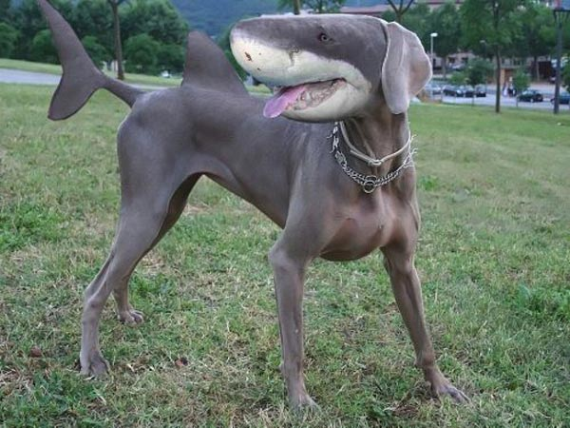

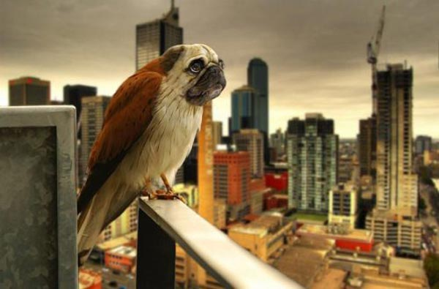

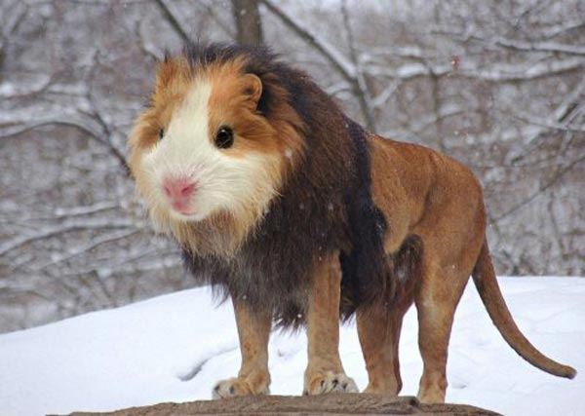

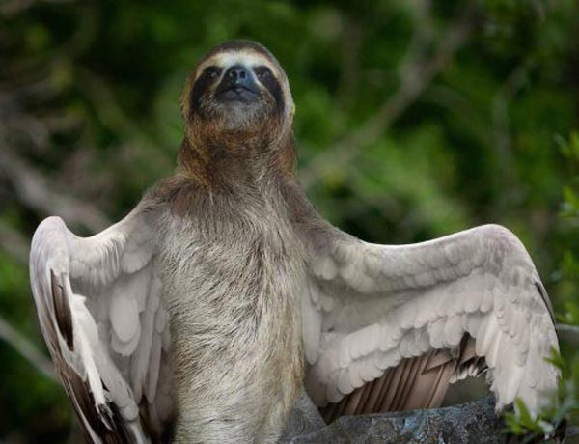

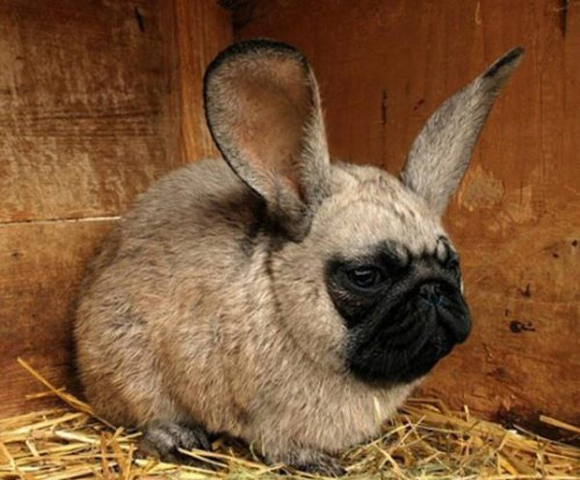

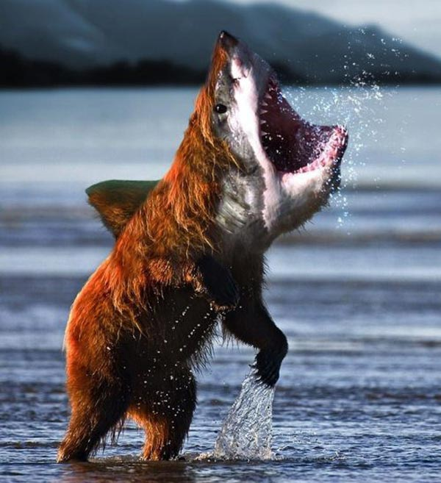

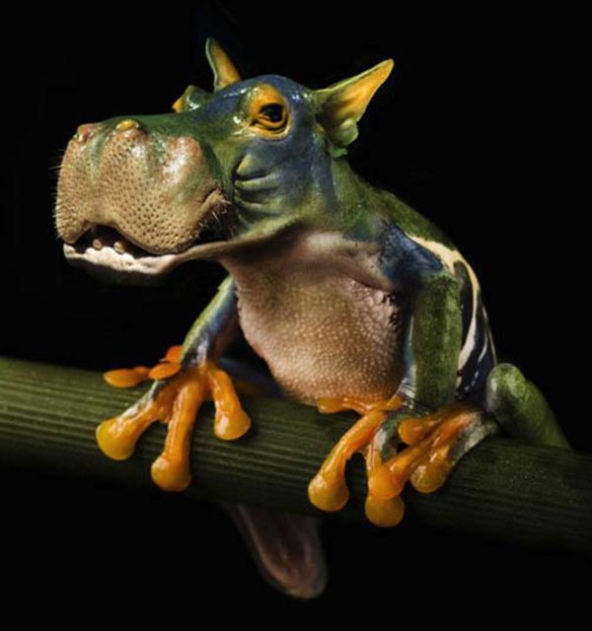

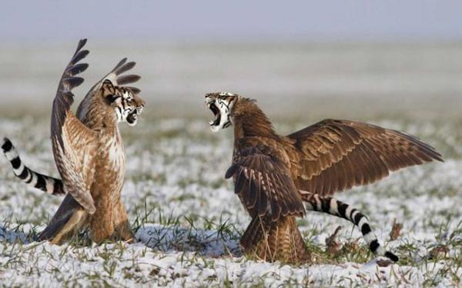

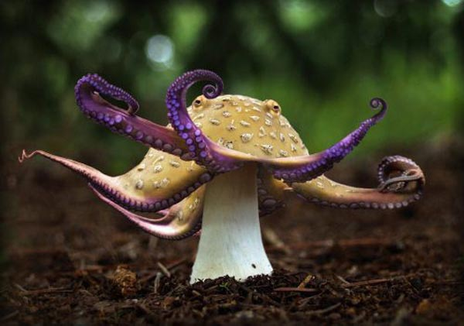

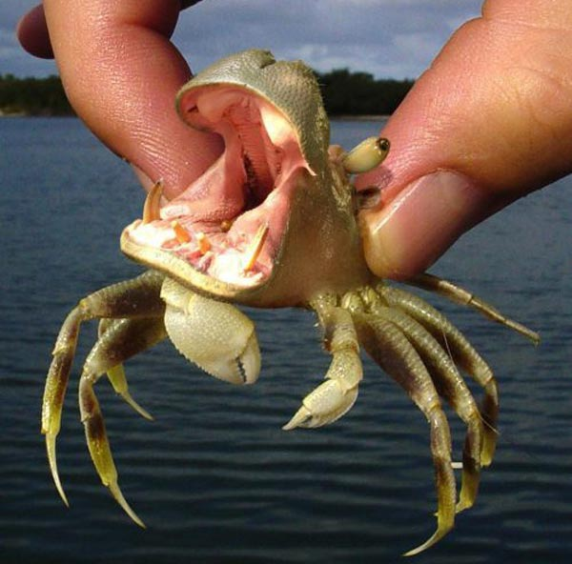

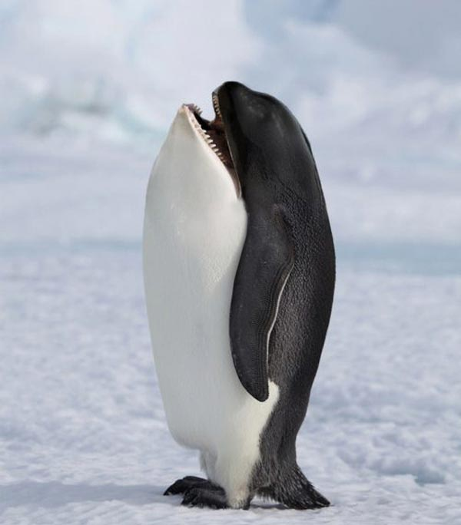

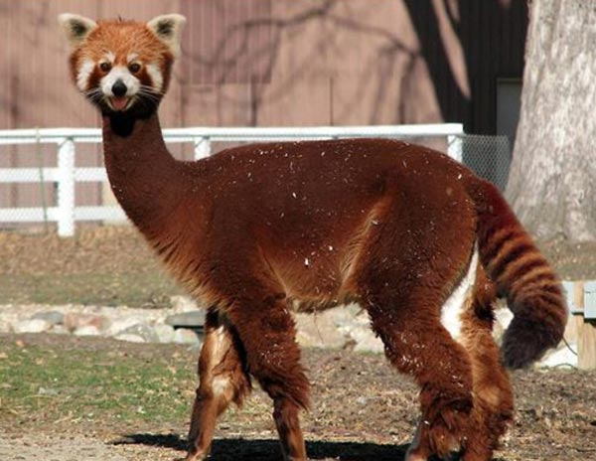

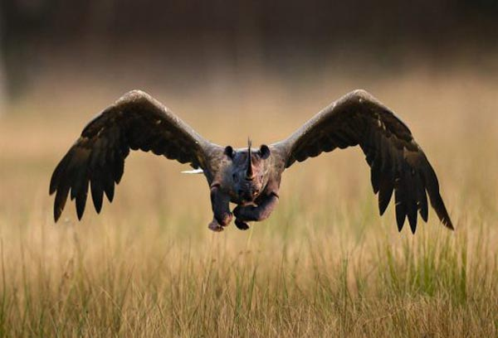

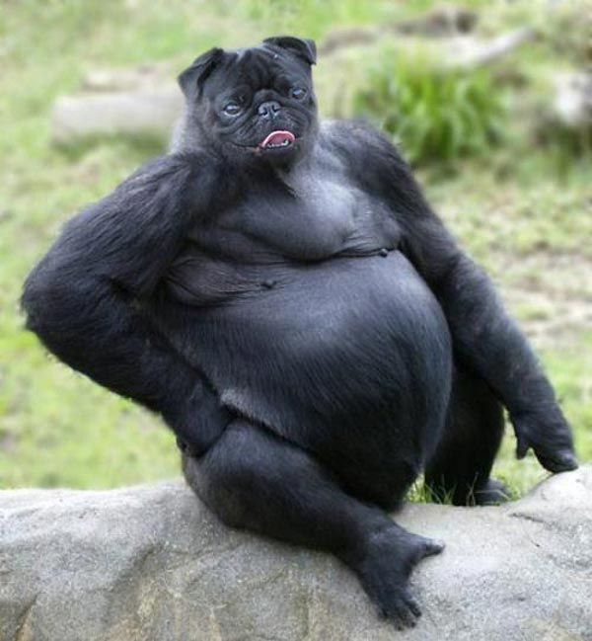



[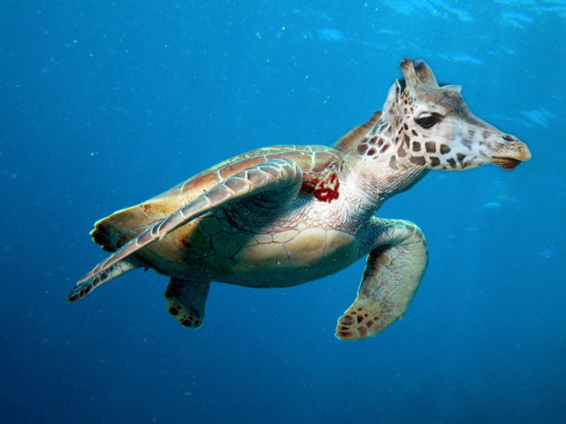](http://www.hybridanimals.org/girtle/)